Lab #4 – Matt Cunningham
Digital Electronics
Combinational Logic Circuits

Objectives:
- Use Quartus to build a multilevel logic circuit using three inputs, three double-input AND gates, a triple-input OR gate, and an output LED.
- Determine the timing diagram based on the inputs and output given.
- Determine the truth table of possible outputs based on possible inputs by manipulating the switches on the board
Equipment Used:
- DE10 Development Board
- Quartus 18.1 Software
Procedure:
- Setup Quartus to create a new project
- Configure Quartus settings as required
- Design the logic circuit:
  - Add three inputs (A, B, C)
  - Add three double-input AND gates
  - Add a triple-input OR gate
  - Add a single output
  - Connect inputs C and B to AND0 (Becomes CB)
  - Connect inputs B and A to AND1 (Becomes BA)
  - Connect inputs A and C to AND2 (Becomes AC)
  - Connect CB, BA, and AC to the OR gate
  - Connect the OR gate to the output
- Run a simulation of the timing output
  - Set timing to 800 pico seconds
  - Set input C clock speed to 25
  - Set input B clock speed to 50
  - Keep input A clock speed at 100
- Connect DE10 board to system
- Use PIN planner to assign pins to our inputs
  - Input A = PIN_D12
  - Input B = PIN_C11
  - Input C = PIN_C10
  - LEDR0 = PIN_A8
- Test truth table logic by switching the applied input switches in the various configurations, to determine if the LED turns on appropriately based on the truth table output
Results:
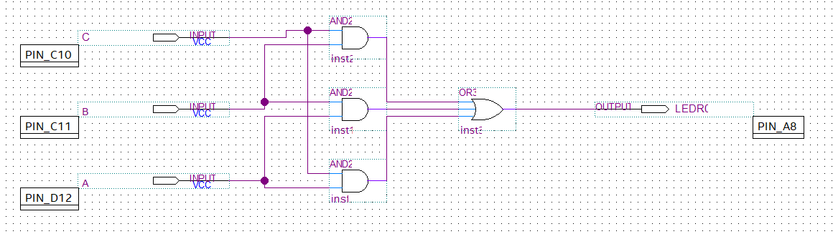
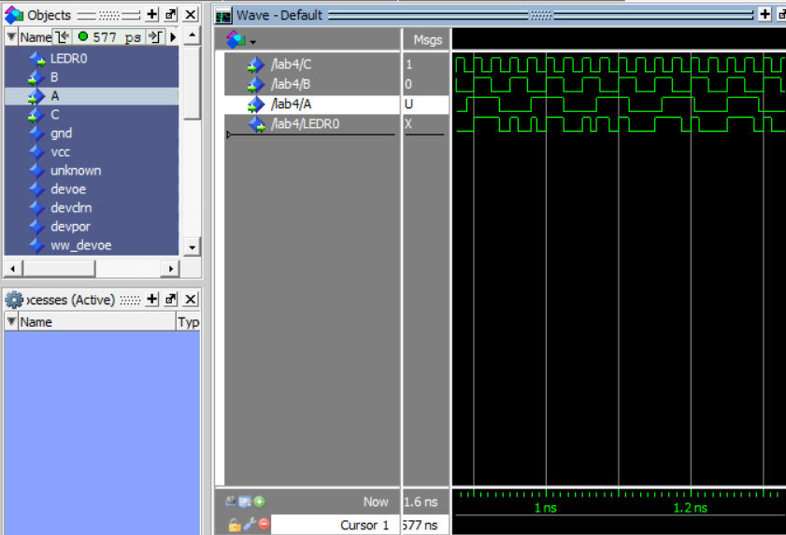

Conclusion:
The circuit is working properly and I have demonstrated it to my professor. The truth table has been verified as working correctly based on all switch permutations. I learned how to effectively program the DE10 board

